# Introduction to the study

## Background to the project

Working with an in-course assignment at Asia Pacific University can be a little bit inconvenience for all parties; students, lecturers, and administrators. Submitting a hardcopy attached by a cd that contains the softcopy assignment causes a lot of internal and external problems. Dealing with hardcopy assignment is a very exhausting not only for the student but also for lectures and administrators. Environment issues, losing students documents, time and money consuming are some problems that every university face. Every University should consider all of these problems and overcome them and make working with assignment and researches easier and convenience especially these universities who specialized in Information Technology.

An online assignment submission system is a project that aims to help and solve all problems that people face in the university. The project enhances the experience of assignment by providing one place for end-user, and it is accessible everywhere. it will use the approach of online assignment portal that is used in most of the top universities around the world follow, which is give a better experience for all parties, and it solves most of the problems especially environments issues.

There are serval reasons that the university needs to adopt this project. The main purpose is to decrease the usage of the material like papers and CDs, which leads to solving the environmental issue that every single human being should consider. In addition, information technology makes our life easier. Arranging students' assignment is difficult to process for administrators and lectures, with this project everything is well organized automatically for lectures and administers. Online assignment submission system shall adopt the latest technology to achieve its objective and fulfill all the users' needs.

# 

## 1.2 problem context

Submitting a soft copy assignment might be complicated especially when dealing with CDs. Mass of problems might occur when student try to burn their soft copy assignment into CDs. First, burning issues. Students encounter burning issue some of them do not know how to burn a CDs and others their laptops do not support burning CDs. Thus, the student might need to ask their friends to burn for them or they go to find an empty computer lab to burn the CDs. This is a problem consider as a time-consuming problem. Also, some scenarios might happen like students do not find an empty computer lab, or they do not find someone to help them with burning the cd. As a result, in some cases, time does not help student so they miss the chance to submit their assignment on the exact due date. Second material waste. Recycling is the hottest topic that all people, organizations, and countries must take care of. Each student uses at least 10 CDs per year. It is a huge amount of material wasted every year. In my opinion, students do not need to use a material stuff to submit their soft copy assignments. As long as it is a soft copy, it should be submitted online. So, submitting online helps to improve the environment and get rid of waste materials. Third, lectures also faced problems when dealing with soft copy assignment. Imagine a class of 60 students and they have been assigned to an individual assignment, so logically every student will submit his or her soft copy assignment inside CDs. Therefore, the lectures will be forced to insert 60 cd to his or her laptop 60 times one time for each student. This process might take a long time to finish and of course, it is exhausting. Other problems have high chances to occur such as losing the student cd. It is difficult for students to prove that they have attached their soft copy along with their hard copy. Once the cd is lost, all the student effort has wasted.

Other problems that students encounter with assignment are assignment grades and lecturers feedback. The only way for a student to know their assignment grade is by visiting the administrator. Students wait for a long queue in the admin just to ask about their assignment result. In addition, after students get their mark from admin they do not know why they got this specific result, so they do not receive their lecturer feedback.

## Rational

According to the problems stated above, an online assignment submission system will be a standalone web application which allows students to submit their assignment via an online portal. Essentially, the system will make working with assignment more easy and convenient. The overall system will be like an assignment community that connects students and lectures together. A lot of features are going to be provided by the system that will solve all problems that mentioned above. The system will provide an easier approach for students to submit their assignment. Furthermore, it gives the lectures easier access to all students' assignments. Another benefit of the system, students will be able to view their assignment result. In contrast, lecturers are encouraged to write feedback about student assignment and explain why he or she assigned this specific result. Moreover, lecturers can assign and update due date of the assignment through the system. Due date of the system will be visible to students inside the system for each module. Besides that, one of the features in the system is the notifications. The student will receive an automatic email once the due date is assigned or updated, also when the assignment is published. An email notification will overcome the problems that student might face especially when the due date is updated.

## Potential Benefits

There are plenty reasons to justify why we need to adopt online assignment submission system. These reasons are divided into two categories, tangible benefits, and intangible benefits.

### Tangible Benefits

The first tangible benefit is a greener environment. The environment must always be a high priority for any organization. Online assignment submission should decrease the usage of the material in the university weather the material is paper or CDs. Another benefit which linked to the first benefits is money saving. Decreasing of using materials leads to saving students money. Printing unnecessary paper and buying CDs is a money consuming for students. Thus, the new system is going to benefits the students financially. Besides that, quick transportation of assignments. Submitting the assignment online is quicker than the traditional way. As long as the system provides one place to submit and it accessible everywhere, the submission process is going to be faster and easier which is going to benefits both students and the administrators. Arranging the assignments online, reduce the workload for lecturers and administrators. Lecturers do not need to manually track who fail to submit assignments on time, and the administrators are not forced to manage and arrange the assignment which also is going to save storage spaces. Moreover, the system is going to enhance the assignment experience for students and lecturers by proving features like due date reminder and assignment assessment.

### Intangible Benefits

The first intangible benefit is all the assignments is going to be secure and safe. There is no fear of losing documents or manipulating the documents. All the documents must be protected, reading view only. In addition, the ability to track the assignments. Reporting and analysis the assignment is easier and done automatically through the system. Even, the ability of detect plagiarism easily.

## Target Users

The target end-user for this project are students, lecturers, and administrators. All these different users have different functions in the system. The students can download assignment question, upload their assignment, checking due date and their result, and ask questions. Lecturers can upload and download assignment, assign and update due date, assess student assignment and write feedback. Lastly, administrators can arrange intake modules and students lists.

## Scope and Objective

### Aims

The purpose of the online assignment project is to enhance the assignment experience for students, lecturers, and administrators. By creating a web-based system that can handle and organize all issues that related to assignments, thus working with assignment shall be easier and convivence. The system is going to help students to easily submit their assignment wherever they are. In addition, it helps them by displaying the due date and their assignment result, also it connects them with their lecturers. Besides the students, the system is going to help lecturers to organized and manage the system. Eventually, online assignment submission is should increase students and lecturers' performance. The expected results are less late submission, easy access for lecturers to all students' assignments and the better working environment when dealing with assignments.

### Objective

The objective of the project is to develop a web app to handle all students’ assignments. The system is going to have many features to improve assignment experience for students. First, system should allow lectures to upload assignment questions to the system and assign the submission due date. When the question is uploaded and due date is assigned, an automatic email will be sent to all students who are taking the subject. Students can download the assignment questions and check the due date which is shall be displayed in the web page. Second scenario of the system is submitting the assignment and receiving the assessment. Students upload their assignments before on the due date. Lectures download all students’ assignments to assess the assignments. Lecturers will be able to send feedback to the students about the assignment and publish students’ assignment results. When the result is published, an automatic email is sent to all students to remind them about their result publication.

### Deliverables

The objective of assignment submission system is to enhance students experience when working with assignments. The objective is to fulfill the end-users needs to give the best environment to handle their assignment. The system allows the student to submit and upload their assignment online by using the web app. Then, the lecturers can keep track all students' assignment through the system. The system will ensure best sharing documents experience between lecturers and students. The System should provide features that make it more convenient to work with the assignment. Down below all the core functionalities that the system shall have before deliver the final project:

**Students Functions and features:**

* The system allows students to log in and out the system
* The system allows students to download assignment question
* The system allows students to submit their assignment online
* The system allows students to check their assignment assessment
* The system allows students to read feedback from lecturers
* The system allows students to ask and answers each other questions
* The system allows students to check assignment due date

**Lecturers Function and features:**

* The system allows lecturers to upload assignment questions
* The system allows lecturers to assign and update due date of the assignment
* The system allows lecturers to send email to all students using one message
* The system allows lecturers to mark students’ assignments
* The system allows lecturers to write feedback along with students’ grade

**An automatic feature that occurs when some functions are done:**

* An automatic email will be sent to all students when assignment questions are uploaded, and when the due date is assigned or updated

An automatic email will be sent to students when their assignment assessment is published

### Nature Challenges

First of all, I need to fulfill the user browser experience. Each student and lecturer use their favorite browser, so I need to ensure best browsing experience for all users. In addition, I must take care of all different browser version and make sure that the web application does not clash when using a particular browser. Moreover, one of the interesting topic when developing a web app is making the web app responsive. Basically, students and lecturers will be using their different screen size devices. So, it is necessary to develop a web app that is compatible with all different screen size devices to fulfill the user experience while using the app. Another challenge is the designing the database structure. The designing database structure is a complex topic, especially when working with a system that requires a lot of data and relationships between data like this assignment submission system.

Despite the technical challenges, researching challenges will come across. Managing the requirement of the system is a little bit ambiguous. Two elicitation methods will be carried by me to gather more useful data to meet all students and lecturers needs. First technique will be handled is a questionnaire. The disadvantage of this approach is usually the result is not accurate. Another problem is the difficulty of convincing the students to participate in the questionnaire. The second technique is observation. I will conduct a research about universities that already use the system, and study how the system is built and study the end-user behaviors and their experience.

## Report Overview

For this project, a research will be conducted to find a useful information to help with the development of the project. The report will view different aspect of the project developments, the following assumption is what is should be found for each chapter.

**Chapter One:**

For chapter one we overview the problem context and problem background. According to the problem mentioned above the proposal system has been identified along with its end-user. Furthermore, the aim and objective has been stated and approved. System benefits has been overviewed and identified along with the development challenges and obstacles.

**Chapter two:**

Literature review of the system that discuss some finding and research from universities or experts about online assignment system. Gathering information about the system and its domain. Searching about the nature of challenges and statistic of the system according to other universities experiences. In addition, discuss about similar systems, its benefits, challenges and its software model.

**Chapter Three:**

This chapter is about technical research about the system development. Throughout this chapter, the technologies that is going to be used is going to be identified. What language is choosing for backend, what kind of database and what IDE and tool is going to be used to implements the system code.

**Chapter Four:**

This chapter is about system development methodology. Through this chapter, the system development methodology is going to be identified with a justification of why this exact methodology is chose. In addition, overview how the system development process going to be by using the system development methodology.

**Chapter Five:**

For this chapter, a research about requirement elicitation techniques is conducted. Search and discuss about elicitation techniques and which of them is suitable to get a better result about user needs. Also, it shows how data gathering increase the changes of project success and reduce the danger of late delivery and overestimate the budget. After the research is done, the elicitation techniques are going to be chosen and designed and publish to the public.

**Chapter six:**

This chapter is finding of the elicitation process of chapter 5. When the elicitation is done, I am going to verify and analysis the questions and answers of the elicitation. The analysis is going to lead to get a foundation requirement of the system.

**Chapter Seven:**

This chapter is about defining the software structure of our system. It describes how our system should be build, data flow, data structure, component interaction and user interface design etc.

**Chapter Eight:**

Chapter 8 describe the project plan of implementing the system and release the product. It shows in detail the process dates of the implementation and the release date.

**Chapter Nine:**

For this chapter, screenshots are taken from all the system pages plus screenshots of the implementation code.

**Chapter Ten:**

After the system is done, unit testing and user acceptance will be conducted to test the functionality of the system.

**Chapter eleven:**

Conclusion of the report is about overviewing the finding of the research, how the finding is going to increase the chances of project success and how to avoid project failure.

## Project Plan

|  |  |  |  |  |  |
| --- | --- | --- | --- | --- | --- |
| Task ID | Task Name | Duration | Start By | End By | Status |
| C1 | Introduction | 8 Days | 13/2/18 | 20/2/18 | Done |
| C1-1 | Project Background | 1 Day | 13/2/18 | 13/2/18 | Done |
| C1-2 | Problem Context | 1 Day | 14/2/18 | 14/2/18 | Done |
| C1-3 | Rational | 1 Day | 15/2/18 | 15/2/18 | Done |
| C1-4 | Potential Benefits | 1 Day | 16/2/18 | 16/2/18 | Done |
| C1-5 | Target User | 1 Day | 17/2/18 | 17/2/18 | Done |
| C1-6 | Scope and Objective | 2 Day | 18/2/18 | 19/2/18 | Done |
| C1-7 | Project Overview | 1 Day | 20/2/18 | 20/2/18 | Done |
| C2 | Literature Review | 8 Days | 21/2/18 | 28/2/18 | Done |
| C2-1 | Domain Research | 4 Days | 21/2/18 | 24/2/18 | Done |
| C2-2 | Similar System | 3 Days | 25/2/18 | 27/2/18 | Done |
| C2-3 | Summary | 1 Day | 28/2/18 | 28/2/18 | Done |
| C3 | Technical Research | 10 Days | 1/3/18 | 10/3/18 | Done |
| C3-1 | Programming Language | 2 Days | 1/3/18 | 2/3/18 | Done |
| C3-2 | IDE | 1 Day | 2/3/18 | 2/3/18 | Done |
| C3-3 | Libraries and tools | 2 Days | 3/3/18 | 5/3/18 | Done |
| C3-4 | Database Management system | 2 Days | 6/3/18 | 7/3/18 | Done |
| C3-5 | Operating System | 1 Day | 8/3/18 | 8/3/18 | Done |
| C3-6 | Summary | 1 Day | 10/3/18 | 10/3/18 | Done |
| C4 | SDM | 6 Days | 11/3/18 | 16/3/18 | Done |
| C4-1 | SDM Selection & Justification | 2 Days | 11/3/18 | 12/3/18 | Done |
| C4-2 | Describe Selected SDM | 2 Days | 13/3/18 | 14/3/18 | Done |
| C4-3 | Project Overview with SDM | 2 Days | 15/3/18 | 16/3/18 | Done |
| C5 | Research Method | 6 Days | 18/3/18 | 23/3/18 | Done |
| C5-1 | Introduction | 3 Days | 18/3/18 | 20/3/18 | Done |
| C5-2 | Design | 3 Days | 21/3/18 | 23/3/18 | Done |

|  |  |  |  |  |  |
| --- | --- | --- | --- | --- | --- |
| C6 | Requirement Validation | 6 Days | 25/3/18 | 30/3/18 | Done |
| C6-1 | Analysis Data Collected Through Questionnaire | 5 Days | 25/3/18 | 29/3/18 | Done |
| C6-2 | Summary | One Day | 30/3/18 | 30/3/18 | Done |
| C7 | System Architecture | 14 Days | 5/4/18 | 18/4/18 | Done |
| C7-1 | Introduction | 1 Day | 5/4/18 | 5/4/18 | Done |
| C7-2 | Abstract Architecture | 5 Days | 6/5/18 | 10/5/18 | Done |
| C7-3 | Database Design | 4 Days | 11/5/18 | 14/5/18 | Done |
| C7-4 | Storyboard | 4 Days | 15/5/18 | 18/5/18 | Done |
| C8 | project plan | 6 Days | 20/5/18 | 25/5/18 | Done |
| C8-1 | Features Plan | 2 Days | 20/5/18 | 21/5/18 | Done |
| C8-2 | Release Plan | 2 Days | 22/5/18 | 23/5/18 | Done |
| C8-3 | Test Plan | 2 Days | 24/5/18 | 25/5/18 | Done |
| C9 | Implementation | Two Months | 1/6/18 | 1/8/18 | Done |
| C10 | System Validation | 10 Days | 3/8/18 | 12/8/18 | Done |
| C10-1 | Unit Test | 8 Days | 3/8/18 | 10/8/18 | Done |
| C10-2 | User Acceptance Test | 2 Days | 11/8/18 | 12/8/18 | Done |
| C11 | Conclusion | 2 Day | 15/8/18 | 16/8/18 | Done |

# Literature Review

## 2.1 Introduction

The literature review is an informative, critical, comprehensive, analytical and useful synthesis of a collection of literature on a particular topic that is usually used as secondary data collection, analysis process and an alternative to primary data collection. Besides that, the literature review formats are commonly written as an introduction and foundation for a research study and systematic reviews. In additional, the literature review used to provide a summarized discussion and examination of evidence in a certain area.

Online assignment submission is a system which seek to help universities manage their assignment online instead of using the traditional way by using hardcopy assignments. However, some important aspect of the system must be thoroughly comprehended before starting to develop the system to ensure implementing a successful product. Furthermore, this research is going to review some literature review to analysis the recent emergence and contemporary efficiency of the system. In this study, the literature review will cover academic works such as journal and universities studies. Aside of that, the literature review chapter is partitioned into two sections, domain research and similar system.

## 2.2 Domain Research

Many universities use assignment and research to assess students’ performance during the semester. Most of these universities use a typical assignment lifecycle starts with collecting assignment, stamping collection date, send assignments to the lecturers and finally lecturers return their assessment. Using the traditional approach for assignment is exhausting process and produce many difficulties and challenges. As a result, recently there are a worldwide interest to use online assignment submission system to manage students’ assignments. Managing the assignment online has three main characteristics; quick transmission, digital storage and automatic analysis and report. These characteristics can solve problems related to the traditional approach and make working with assignment more convivence. First of all, assignment online system and provide faster assignment delivery than the traditional way. A study conducted by the Open University of Hong Kong discovered from his research that assignment submission lifecycle reduced from two weeks to only two hours. (Mak, 1999) . Furthermore, another study from Open University United Kingdom discovered that students experienced a decrease of assignments due date from two weeks to one week after adopting the assignment online submission system. (Petre, 1997) . secondly, digital storage benefits. This benefit can solve packaging problems, each day the university received many assignments from students which make the administrators face a problem of packaging all assignments. Thus, by using online assignment submission system, then no packing required by the stuff and the system should organize all the documents automatically. Besides that, faster assessment. Due to the simplicity of accessing the assignments, lecturers feedback about the system found that it is easier to assess the assignments than the traditional approach. A study shown than assessing online assignments is 30% less time average than assessing the hardcopy assignments. (Jones, 1997) . In addition, some universities use second marker to assess the assignments, by using the central storage assignments can be accessible from everywhere and prove the it takes less time to assess comparing to the traditional approach. Finally, the ability to analysis and report. Duke University conducted a study discovered that about 80% of two thousand and one hundred students had committed a plagiarism offense at least once. (Quan, 2001). However, using the online submission system to detect plagiarism with help of other third-party systems make it easier to detect plagiarism. (Jones, Online Assignment Management: , 2002)

Unisa Business of School conducted a survey to gain a view of markers perspective about paperless assignments. The survey was done by using online survey system and was sent to lecturers through email. The main aim for the survey was getting lecturers perspective to contribute enhancing the system. The figure below shows the question used for the survey.

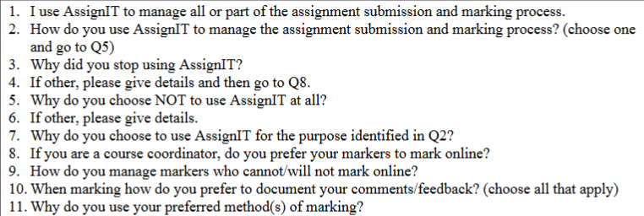

However, the survey results reveal many aspects about lecturers respective about the paperless assignments. Figure below shows that 84% of the lecturers always use the system, 11% of then never use it and use the traditional approach instead, and 5% have used it but they no longer use it.

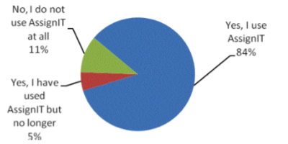

The upcoming figure revealed how lecturers have been using the system. the figure indicates that 63% of the lecturers use it only for submission and they don’t return the result or give feedbacks. 9% of the lecturers have used it for submission and returning the grades while 6% used it for submission and returning grade and writing feedbacks. Finally, 22% of the lecturers got the benefits of all the system features.

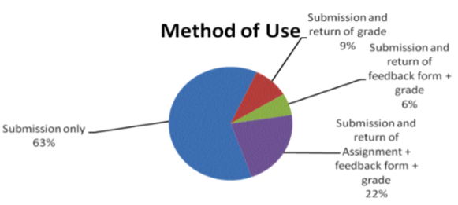

(Barker, 2008)

## 2.3 Similar System

**Blackboard Learning Management System:**

Blackboard Inc. identified as an entrenched creator of teaching software which delivers influential and flexible eLearning platform software for educational industries since more than 10 years. Part of the Blackboard education and instruction purposes are to bring content management and sharing, cooperation and software collaboration which contains - online assessments, students’ progress tracing, grading and task management, as well as make, assess, investigate, and control data about of university activities all at once. The functions enable tutors, admin and students to share and learn materials in a web app online as virtual campus system. Some of the various functions;

* Program creation and Management – program central storehouse, manage and generate program online, and the management of content updates. The program contents could be modified and allow information reuse. hyperlinks, slides, diagrams, images or other audio/video documents could be shared.
* Assessment and Grading – Publish and assign assignment due dates with capability to view and edit assignments for assessment drives straight from the browser. Students can view an assignment due date and deliver the assignment online and check if the assignment result have been published. Reliable assessment in parallel with the evaluation process while writing feedback on the students’ performance.
* Track Progress - tutor Control panel track evaluation and progress such as tracing each student practice of program. Tutors can track on all students during the program including tracking students’ assignment. Time and Date receipt are available for identification of late submission.
* Calendar: tutors able to use this feature to set deadlines for test and assignment.
* Retention Center - Retention issues to student behavior to the tutors’ attention, fast warning the student possible risk and allowing tutor to act immediately. This feature allows to assist students when they start to show signs of dropping below the expectation in their program. The feature allows by tracking their performance in missed due date, current grades, program activity and program access (Rahman, 2016)

## 2.4 Summary

In summary, this literature review reveals many aspects about the systems. It shows the statistics and experience of the system that is implemented by different branches of Open University. In addition, it shows lectures behaviour to the system. The figure proves that 80% of the lectures are comfortable to use online assignment submission instead of the traditional way. It proves the success of the system and it benefits and satisfied the end-user.

Besides that, Similar system gives a sight of the necessary features that is used to help students with their eLearning path. It shows features like manage classes, grades, assessment, communication and collaborative how it used and what its benefits.

# Technical Research

## 3.1 Programming language chosen

The programming language that chooses to implement Online assignment submission system is JavaScript ES6 version. JavaScript is interpreted, lightweight and object-oriented programming language. It is a dynamic programming language and supports both object-oriented and functional programming paradigms. (Mozilla Org, 2018)

JavaScript was released on 4th of December on 1995 by Brendan Eich who was an employee of Netscape Company at that time. JavaScript was built to work on the front page on the website, which is used to design how web pages interact with end-user and how to behave when an event occurs. (Mozilla Org, 2018).

**Why is JavaScript the chosen one?**

The first reason to use JavaScript is free to use. JavaScript consider as the most open programming language as it was stated on ECMA-262 specification that all browser vendor and other companies can take over JavaScript to make a better language that could be. Secondly, JavaScript is wide range used. JavaScript is used on a web application for both client and server sides, desktop application and cross-platform mobile application. As it wide range used, JavaScript is one of the highest demanded languages in 2018. Thirdly, JavaScript tools. JavaScript has a lot of tools that lead to enhancing your application code and system scalability and productivity. Examples of tools that are going to implement on the system, NPM package manager, NPM scripts task runner and Webpack.js module bundler. Finally, JavaScript has a powerful community out there. According to GitHub statistics, JavaScript is most popular language on GitHub, there are 2.3M JavaScript Project on GitHub. (GitHub, 2018).

(Rauschmayer, 2014)

**Languages Comparison:**

**JavaScript VS PHP:**

It is known for years that JavaScript is a front-end language while PHP is a back-end language, but rules have changed in 2009 when Node.js was release. Node.js is JavaScript runtime environment that runs on the server side. The advantage for PHP over Node.js is simplicity. PHP is simple comparing to Node.js when setting the server, Node.js require more code that PHP to run the server while PHP all you need is to be wrapped it inside PHP tag. While simplicity advantage goes for PHP, Node.js take advantage over PHP at concurrency. Almost every back-end language using blocking I/O to handle the multi-task in parallel, this what makes Node.js is unique that uses non-blocking I/O execution model that execute one main thread.

(SHIOTSU, 2018)

## 3.2 IDE (Interactive Development Environment) chosen

Visual Studio Code is the source text editor that going to be used for this project. It is a cross-platform text editor developed by Microsoft. It is one of the most popular editors that support many different languages with a lot of features that help developer productivity. Visual Studio Code helps you with syntax highlight, auto indention, snippet and keyboard shortcut for faster development. It also enhances development experience by supporting debugging and embedded version control GIT. (Microsoft, 2018)

## 3.3 Libraries chosen / tools chosen

The primary library that is going to be implemented for this project is React.js. React.js is a library to build user interface written in JavaScript language. It is maintained by the Facebook company and first released on 2015. The most important feature which makes React.sj so powerful library is JSX feature. Instead of using complex JavaScript template, JSX allows you to merge JavaScript inside HTML code. JSX runs faster than any equivalent JavaScript code. In addition, JSX is safe while it is statically-type and type-safe. (Dena.com, 2018)

Beside React.js, another library is going be implemented is Redux.js. Redux is open-source JavaScript library to manage application state. It was developed by Dan Abramov and Andrew Clark. It is a state container for your application, helps your application to behave consistently. It can be used with React.js or angular.js (Redux.Org, 2018)

Besides libraries, there are various tools to improve development experience. As long as it mentioned above that latest JavaScript version ES6 and beyond is going to be implemented for this project, we must use Babel.js to compile our code into ES5. As a web developer, it is important to consider that different user use different browser. Because of most browsers do not support ES6 feature, when must use JavaScript compiler to compile ES6 code into ES5 otherwise, our code will be useless. Solving this problem require using the babel.js compiler in our application. The second tool to use is Eslint.js. it is popular to JavaScript developers following a standard rule of writing code to make their code easy to read and understand so they could collaborate. The third tool to use is Webpack.js. it is JavaScript module bundler; its purpose is bundle JavaScript file for usage in a browser. Finally, the most important tool is version control GIT. Git is a useful tool when you are part of the team. it provides you a local copy of your file and allows you to work offline or remotely. You can get benefit from Git when you work independently as it can manage and track your files and repository. (Microsoft , 2018)

## 3.4 Database Management System chosen

There are two primary types of database structure, rational database (SQL) and non-rational database (NoSQL). Each structure built and used in a different way, while a rational database is organized and structure in tables that have relations with other tables, non-rational database store all the data into one file document. Thus, the best structure to choose for this project is Non-rational database structure. There are serval reasons for selecting a non-rational database. First, with the document-oriented database, you can store limitless type of data and define the data is not required. Second, use could-computing storage. The non-rational database takes most advantages of could computing and storage which helps to save cost. Final, non-rational database is faster development than the rational database. The selected database is MongoDB. It is non-rational database founded in 2007, and it was writing by using C++. MongoDB is a schema-less and hash-based database which uses BSON format.

(WODEHOUSE, 2018)

## 3.5 Operating System chosen

Single page applications that build using React.js are cross-platform, it can be developed at all different operating system Windows, Linux, and Mac. However, for this project, I am going to use Windows 10 operating system.

## 3.6 web browser chosen

The web browser that is going to be used to test and debug the system is Google Chrome. Google Chrome provides developer tools option to enhance development experience for faster development and easy debugging. It helps you inspect DOM element, debugging JavaScript, track network performance and improve rendering performance.

## 3.7 Summary

In summary, the technical research reveals the development tools that are going to be used to help to achieve the objectives of the project. All the tools that are selected based on required software quality. Using node.js as a backend to get the benefits of its performance and scalability. In addition, using MongoDB as a database to achieve data scalability. For front-end, React.js is the primary library that is going to be used to build a reusable user interface component.

# System Development Methodology

## 4.1 Introduction

System development method refers to frameworks that control, plan and manage the process of developing a software. There are various different methodologies evolved in software industry all over the years. Each methodology has its own advantages and disadvantages, also each one of them is suitable for a particular type of products based on business requirement. Nevertheless, for this project, Online Submission System is going to be developed by the most suitable methodology to manage the development process and deliver the product on time. Through this chapter, the system development method is going to be identified, justify the reason of the selection and an overview about the selected methodology phases. (Center for Medicare & Medicaid Services, 2018)

## 4.2 Identify the chosen methodology

Choosing the suitable system development methodology depends on various factors. A software engineer must take in mind some factors before selecting the methodology, and these factors depend on following points. First, project requirement. It is a very critical factor that determines the success of the project, whether the development team has a clear requirement for the problem or not. Usually, if the requirement is not clear enough, the project probably going to fail. Second, the solution. This factor relies on the first factors, with a clear requirement the solution is going to be easier to achieve and develop. Third, feedback. Each different project requires different feedback from the user, some project requires minimal feedback until the final version is done, and some project requires constant feedback from users. Finally, requirement changes and project delay. In software development, you might expect some changes during the development process, these changes might cause project delays. (Krishnan, 2018)

After taking all these factors into consideration, the selected system development methodology is Scrum methodology. It is the framework that applies the agile principle. It is a collection of rules, event, and artifact that help teams to work together more effectively and harmoniously. (Scrum Guide, 2017)

## 4.3 Justify of Selection

Scrum methodology is best suitable when the project delay cost is high and delivery delay must be minimal. Scrum has many advantages that help developer team to proceed the development process to deliver the product one time with less prospect of late delivery, these advantages involve the following:

* Iterative task

The nature of scrum methodology is to split the development process into smaller iterative task called sprint. This approach of development benefits the developer team for faster development and fewer bugs problems. Because of its short-term sprint, the scrum is a fast development methodology with a better deliver quality. Thus, testing and maintaining the function of the project is easier as long as it broken into the subsystem. Earlier testing benefits the developers to remove all mistakes and bugs that occur during implementation. Detecting the bugs earlier benefits the developers to prevent any unnecessary delivery delay, otherwise, delay cost might increase. In addition, getting user feedback frequently. Getting user feedback consistently and get the user involved will improve the delivery quality of the system and ensure it meets the user needs. Another advantage of getting feedback is easy to handle requirement changes. Due to getting a frequent feedback with scrum, it is easier to cope with requirement changes, and the cost of changes is very minimal. The sprint is a short-term period before it starts the developers are planning what to do, and when it is finished, they are going to review and discuss what is done. At the end of each sprint, part of the system must be ready to show the customer or users.

* Team productivity

The scrum team consists of three categories, business owner, scrum master, and development team. Due to the iterative short-term task, the development team has to set up a daily meeting to discuss what has been done and what to do. This leads to improve development productivity when you review the process frequently together and plan what to do next. Also, when the sprint is a short-term period approximately one week to two weeks, the work is divided which is going to produce a better performance from developers and their contribution is going to be clear.

(Malik, 2018) (Adell, 2018)

## 4.4 Overview of Scrum Methodology phases

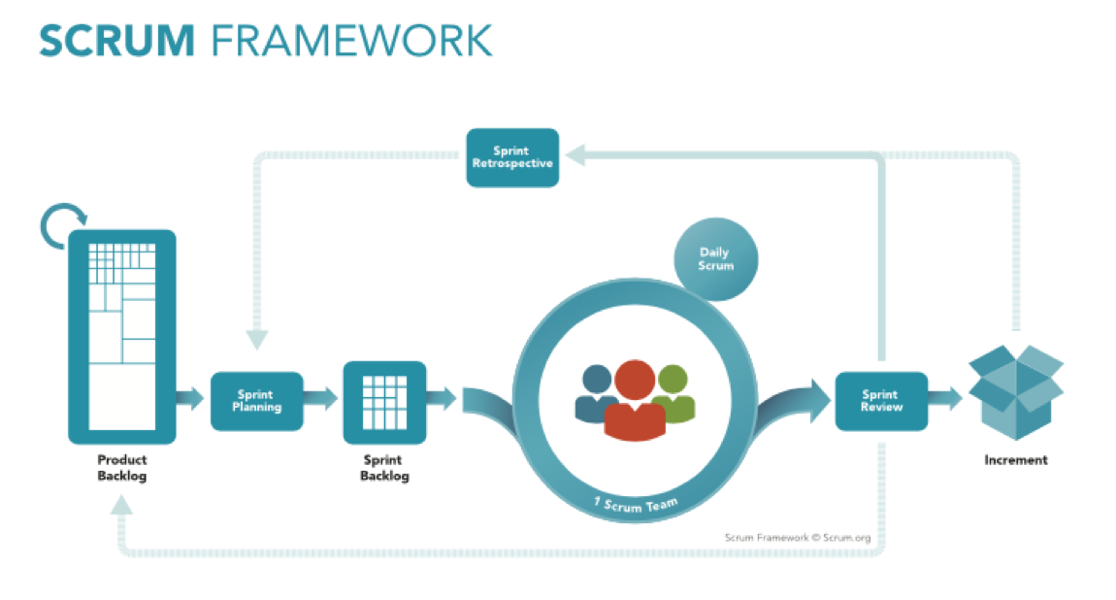

**Figure**

### 4.4.1 What is Scrum methodology?

Scrum is an agile framework helps people to solve difficult problems and build complex products, while creativity and productivity at its highest level. Scrum include three main stakeholders: product owner, scrum master, and development team. Start with the product owners, their responsibilities include explaining what is the product and what is their prioritized features they want for their product. This process called product backlog, it is a set of prioritized features, and it must be visible and clear to the development team. The second stakeholder is scrum master. Its major responsibility is to guide the development team to practice scrum helping them understand scrum theory, values, and rules. Finally, the development team. the development team is the team that works together to get the work done at the end of each sprint. the development team is organized and structured by the organization to handle their work and improve their effect and efficiency. (Scrum Guide, 2017)

### 4.4.2 Scrum Artifact

Scrum's artifacts are the value or word produce opportunities and transparencies to enhance adaption and inspection. The artifacts were designed to increase information transparency that all the stakeholder can understand.

#### 4.4.2.1 Product backlog

The product backlog is the main source of the product requirement and changes. It contains a list of desired product requirement. The people who are in charge of this artifact are product owners. The product backlog is an ongoing process, while the product exists, the product backlog is never complete. The product backlog is dynamic, at early development stages it consists of product initial requirement. It lists feature, requirement, function, and enhancement. When the product gains more value, the product backlog becomes larger especially after getting feedback, business changes, and market condition.

#### 4.4.2.2 Sprint backlog

The sprint backlog is a set of product backlog item selected for the current sprint. it is a plan of what functionality is going to be developed and delivered into done increment. The sprint backlog is a plan occur during the sprint planning. It has enough information that changes in progress can be understood. The development team is the only people who are authorized to change the sprint backlog. They can modify the sprint backlog during the sprint when new work is required. The sprint backlog is a highly visible picture of what the goal of the current sprint, it is also has a status upon the product backlog like performed, completed, updated or removed depends on the requirement and changes.

#### 4.4.2.3 Increment

it is the result of all product backlog that it has been developed during the sprint. The final result must be a potentially shippable product that it can be in a useable condition. The increment is shown to the business owner and gets a feedback from them or it may also be possible to release the product. (Scrum Guide, 2017)

### 4.4.3 Scrum Event

#### 4.4.3.1 The Sprint

The sprint is the heart of Scrum. It is where the product will be a potentially shippable product. It is a time-boxed duration of one month or less. Sprint is an iteration process, once the sprint is over another sprint starts immediately. Sprint consists of many phases to ensure maximum productivity and efficiency to create a potentially shippable product. The phases are sprint planning, daily scrum, the development work, the sprint review and the sprint retrospective.

Sprint split the project into smaller mini projects with the intention to design a plan that helps to accomplish the developing and building of the sprint goal. Furthermore, cancellation of the sprint could be possible before the sprint duration is over. It could be done only by the product owner. In addition, it may also be canceled when the goal of the sprint is no longer useful.

##### 4.4.3.1.1 Sprint Planning

Sprint planning is a process of identifying the goal of the sprint, the work to be performed, and how it will be performed. It is a time-box duration of 8 hours or less. It created by the whole scrum team, and the scrum master ensures to keep the planning within the time-box. The development team works to discuss the functionality that is going to be built during the sprint. it lists the product backlog that must be performed to achieve the sprint goal. The development team also discuss the latest product increment and assess their previous performance of the development. During planning, the development team starts with analysis and design the work that is required to convert the product backlog into a potentially shippable product. If the development team determine that the product backlog is too little or too high, they can renegotiate the product backlog with the business owner to trade-off. By the end of the planning phase, the development team should be able to illustrate how the implementation will be carried out to accomplish the sprint goals.

##### 4.4.3.1.2 Daily Scrum

The daily scrum is a meeting conducted by the development team to synchronize activities and make a plan for the current day. It is a time-box event performed within 15 minutes every day at the same time. The scrum does not participate in this phase but his/her task is to ensure the meeting is done for 15 minutes and ensure that the meeting is conducted only by the development team. During the daily scrum, every member from the development team discuss what they have done to help the development progress and what they are supposed to do today, they also may give suggestion to improve the team productivity to achieve the sprint goal. They use the daily scrum to inspect their progress toward are sprint goal. This daily scrum leads to optimize the efficiency and productivity of the development progress. In addition, it improves team communication, collaboration and removes obstacles that prevent to achieve the sprint goal.

##### 4.4.3.1.3 Sprint Review

At the end of the sprint, sprint review begins to inspect the increment. all the scrum team collaborates to review the sprint process and the final increment. it is a four hours session or less depends on the sprint duration. During the sprint review, the development team explains what went well and what problems they came across and how they overcome these obstacles. In addition, they review how work was done, answer questions about increment and review the budget and timeline. The product owner participates and explains what has been done form the product backlog and what is not completed.

##### 4.4.3.1.4 Sprint retrospective

Sprint retrospective is a phase where the scrum team inspect themselves and make a plan for improvement for the upcoming sprints. It held the sprint review and the next sprint planning, usually happens within three hours or less depends on the sprint duration. During the sprint retrospective, the scrum team inspect their last sprint and look for improvement in the way they handle the work. At the end of this phase, the scrum team shall identify improvement to apply for the next sprint.

(Scrum Guide, 2017)

## 4.5 Project overview with Scrum

Now I am going to demonstrate how the assignment submission system is going to be developed using the Scrum methodology. At the beginning of the process, first I am going to study the problem background along with the proposed solution, and what the main objective and aim of the proposal system. After study the problem background and the proposal, the next step is identifying the stakeholder, which they are students, lecturers, and administrators. Then an interview and questionnaire techniques are going to be held to elicit the system requirements. After getting the requirement, the scrum starts to begin with initial product backlog contains most prioritized requirement. Afterward, a sprint planning is conducted which leads to creating a sprint backlog of the functionality that going to be implemented in this sprint. When scrum planning ends the sprint starts. Within the sprint, a daily meeting is going to be held to discuss what is done yesterday and what to do today. After the sprint period finishes, a potentially shippable product should be ready. When it is ready, a review is conducted to determine what product backlog item is done and what is not done, also discuss what happened through the entire sprint. The final step of the sprint is scrum retrospective, what should be done through this phase is some suggestions and improvement should be revealed and plan to implement this improvement for the next sprint. Finally, to end this sprint a feedback is going to be gathered from the user for the potentially shippable product. After all, these sprint is going to be performed over and over again until the final product is totally built.

## Research Methods

## 5.1 Introduction

Data Gathering and analysis is a crucial part of software development. Software engineering industry experience encourages developers to spend more time to requirement engineering rather than implementing the system. The success of software projects starts with requirement engineering phase. Good requirements increase the chances of successful project and vice versa. There are two kinds of requirements user requirements and system requirements. User requirements are which the users wish to have in the system and what they expect from the system. Usually, these requirements come from people with no technical knowledge. System requirements are the requirement defined by the developers after analyzing users' requirements. System requirements are influenced by many factors like budget, delivery date, software quality and technology constraints. (R.Young, 2014)

The definition of a successful software project is when it is developed and shipped on the due date, developed by the approved budget and meets the user needs. If one of these factors time, budget and quality are unsatisfied it will affect the other factors and leads to project failure. Requirement engineering plays an important role in project success. Approximately 50% to 60% of project failure is due to poor requirement. Poor requirements lead to rework and increase work time for around to 40% of analysis phase and 70% for the implementation phase. Thus, first requirement engineering advantage is to ensure development consistency. (Shubhamangala, 2012). Requirement elicitation is a process of using a different technique to gather and collect requirements from users. It is important for software development to ensure the future product meets user expectation. Using data gathering and analysis help you overcome many problems during the development process. It helps to solve problems of scope, having an insufficient amount of information or too many information one of the reasons for project failure. The second problem is volatility. It is common in software development to face requirement changes during development, so by getting user involvement, it will minimize the required changes. In addition to user involvement, requirement misunderstanding is going to decrease if we use the right requirement elicitation technique and the right end-user. Requirement elicitation has four categories of techniques, a traditional technique which consists of questionnaire and interview, a collaborative technique which consists of the focus group, prototyping, and brainstorming, a cognitive technique which consists of protocol analysis and document analysis. And finally, observational technique. Each technique suits a different kind of project influenced by different factors like application domain, requirement source, and stakeholder.

All in all, requirement engineering helps you to organize and manage your data collected, handling requirement changes and decrease requirement misunderstand. (Riga Technical University, 2016) .

## 5.2 Questionnaire With justification

The questionnaire is a traditional elicitation technique and one of most commonly used technique. It is a sequence of questions with the intention to collect information from stakeholders. The identified stakeholder for this project are students, lecturers, and administrators. By using questionnaire developers can reach as many stakeholders as they could and by getting many of them involve a better result comes out from your survey. When the same question is asked too many people this gives us an advantage of getting different perspective and views. So, the first reason to adopt questionnaire is it could reach to huge numbers of people with no time. In addition, the questionnaire is an economy technique. Designing and analysis the questionnaire does not require a lot of money, it is cheap and easy to deliver it to stakeholders, no meeting required it is done remotely. Thus, the second reason to select questionnaire is inexpensiveness. Furthermore, the questionnaire is a simple technique to conduct. Multiple questions or fill the blank will encourage people to participate. As a result, simplicity is another reason to select questionnaire for this project. Overall, using questionnaire can benefit the developers in many aspects. It could reach to many people within a short time and answers could be analyzed automatically. In addition, technique budget is always low due to its process nature. It just requires a free or a cheap software to do the questionnaire. Finally, it is simple to use which encourage people to participate and get their contribution within a short time. (Yousuf, 2015)

## 5.2 Design

Questionnaire questions

1 - How old are you?

1. 17 – 20 Years Old
2. 21 – 24 Years Old
3. 25 Years Old and above

**Objective:** The objective of this question is get a vision about the average age of sample the university students who are going to participate in this questionnaire

2 – What course are currently studying?

1. English Program
2. Foundation
3. Diploma
4. Degree
5. Master
6. PhD

**Objective:** Understanding of education levels between participates

3 – What Field are currently pursuing

1. Computing, technology, and games development
2. Engineering
3. Business, management, marketing, and tourism
4. Accounting, banking, and finance
5. Other

**Objective:** Getting an idea about participants specialists

4 – How many assignments do you have per semester

1. 1 – 3
2. 4 – 6
3. More than 6

**Objective:** Understand the average of assignment that student take and the repetition of physical assignment submission.

5 - Would you prefer to submit the assignment online rather than physically

1. Yes
2. No
3. Maybe

**Objective:** Estimate students desire to have an online assignment submission system

6 - Do you think hardware assignment submission is a complicated process

1. Yes
2. No
3. Maybe

**Objective:** Check if student struggle with their assignment submission process or not

7 - What about these options is a problem of physical assignments

1. Environment impact
2. Money consuming
3. Time-consuming
4. Assignment loses

**Objective:** Getting students perspective about physical assignments submission problems

8 - What is the best approach to submit an assignment

1. Online Submission
2. Physical Submission
3. Both

**Objective:** Understand students’ orientation for assignment submission approach.

9 - What is the most prior reason to adopt online assignment submission

1. Fast Submission
2. Money and time saver
3. Environment saver

**Objective:** Understand the reason why student prefer online submission

10 - What is your primary concern of online submission

1. Privacy and security
2. Poor internet connection
3. Loss of assignment
4. Assignment Submission receipt

**Objective:** Understand student perspective of online assignment submission limitation.

11 - Would like to have a full system for an assignment related to assignments issues like submission, due date, results, and feedback?

1. Yes
2. No
3. Maybe

**Objective:** Getting students’ opinion of having full system handle all assignments aspects and issues.

## 5.3 Summary

In summary, this survey is going to give a slight idea about students’ perspective for using online assignment submission system. To achieve the objective of this survey, the survey is needed to be spared to a large number of students as possible. Delivery the survey is going to be conducted by using different approach, email, What’s App group, and Facebook groups. The tools used to conduct this survey is google form and get the benefits of their response analysis to analysis students answers. After this stage is done, we are going to have a foundation requirement to start design the system.

# Requirement Validation

## 6.1 – Analysis of data collected through questionnaire

The system’ questionnaire has been standardized and distributed to all individuals who have a relation to the system in order collect a massive amount of information that can be gathered from a big number of users within a short duration of the time and helping the system’ developer in having a knowledge about the all system’ sides and find out the users’ expectations in order to develop a more efficient and effective application. Aside from that, this survey questionnaire has been distributed to the system' users through using social media applications like Facebook, and WhatsApp.

**Question 1:**

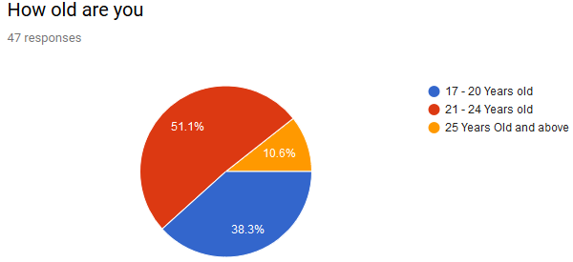

**Objective**: The objective of this question is get a vision about the average age of sample the university students who are going to participate in this questionnaire

**Analysis:** this question revealed the participate ages. Almost around half of the participates are aged between 21 to 24 years old, 38.3% of them are 20 years and below, and only 10.6% of the participant are above 25 years old.

**Question 2:**

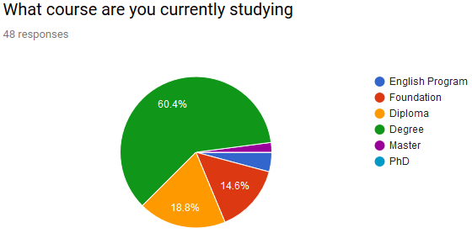

**Objective:** Understanding of education levels between participates.

**Analysis:** The second question provide an info about education level and it shows that 60.4% of the participant's study degree, 18.8% of them a diploma and 14.6% of them are studying foundation program.

**Question 3:** 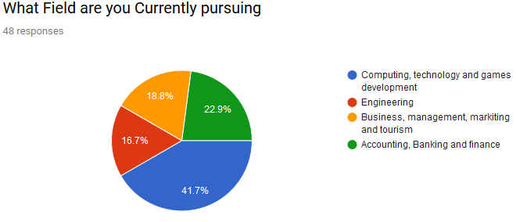

**Objective:** Getting an idea about participants specialists

**Analysis:** As expected, IT specialist has more student that other courses in APU, the figure show that 41.1% of the participant is from computing. 22.9% of the participants are specialized on financial courses, 18.8% of the participant is taking business and management courses whereas only 16% are engineering students.

**Question 4:**

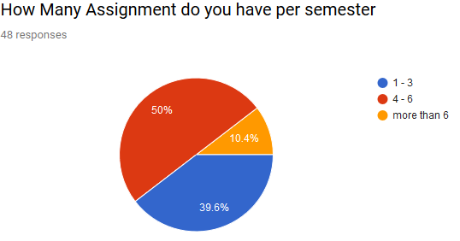

**Objective:** Understand the average of assignment that student take and the repetition of physical assignment submission.

**Analysis:** half of the students have an average of 5 assignment per semester, while 40% of them are having from 1 to 3 and only 10% of the students have more than 6 assignments. This question reveals the huge amount of paper that students use every 4 months during their semester.

**Question 5:**

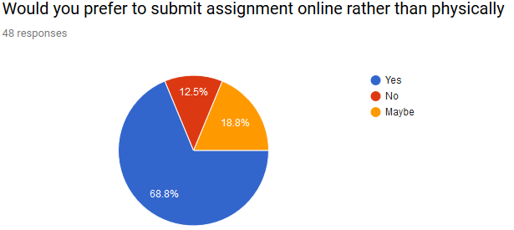

**Objective:** Estimate students desire to have an online assignment submission system

**Analysis:** This question shows that students are willing to use information technology to handle their assignment submission. 68.8% of the students want to have a system that allows them to submit their assignment instead of the traditional way. In contrast, 12.5% do not prefer online submission and 18.8% do not know what is the best for them.

**Question 6:**

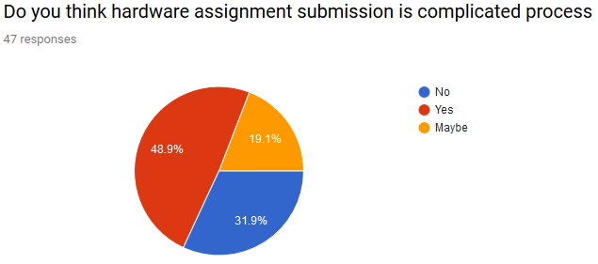

**Objective:** Check if student struggle with their assignment submission process or not

**Analysis:** Printing assignments and burning CD's causes a lot of problems such as long queue at a printing shop, burning CD's difficulties and so on. Almost half of the participant think assignment submission process is exhausting. While 31.9 of the participants think it is not a complicated process, and 19% of them are unsure about their opinion.

**Question 7:**

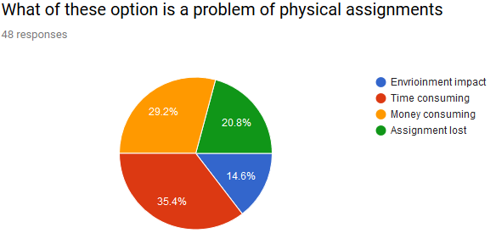

**Objective:** Getting students perspective about physical assignments submission problems

**Analysis:** the traditional approach of assignment submission causes a lot of problems, this question asked students what is the problem with their assignment submission approach. 35.4% of the student said it is time-consuming. They waste more time on printing their assignment and burning their CD's for the soft copy. 29.2% of the students think it is money wasting. They think printing assignment is expensive and consume their money. 20.8% of the students worry about their losing their assignment after submitting it. Finally, only 14% of the students care about the environmental impact.

**Question 8:**

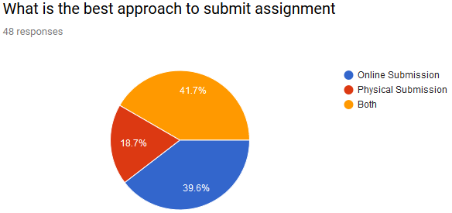

**Objective:** Understand students’ orientation for assignment submission approach

**Analysis:** This question shows students’ orientation to online assignment approach. 39.6% of the students want to submit their assignment online only, while 41% of them prefer both approaches, and only 18% prefer the traditional approach.

**Question 9:**

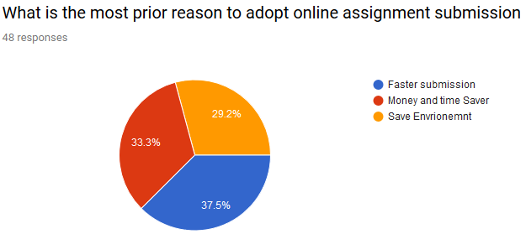

**Objective:** Understand the reason why student prefer online submission

**Analysis:** for this question 37.5% of the students prefer online assignment submission because it is faster than the traditional approach, 33.3% think it saves their money and time, and 29.2% of them wants to reduce papers usage and save the environment.

**Question 10:**

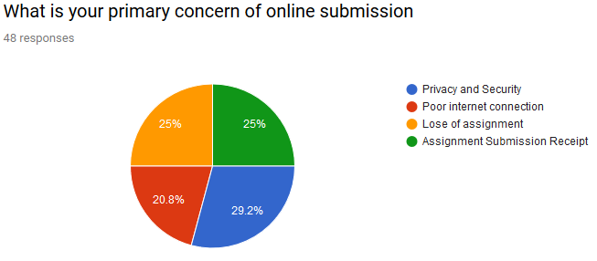

**Objective:** Understand student perspective of online assignment submission limitation.

**Analysis:** The issue that students worry about is privacy and security. 29.2% of the students are worried about privacy and security. Another issue is assignment lost whereas 25% of the students are worried about. Same numbers of the students think about assignment submission receipt, they think about system reliability and failure of submission the assignments. Finally, 20% of the student think poor Wi-Fi connection might be a problem they would face with their assignment submission.

**Question 11:**

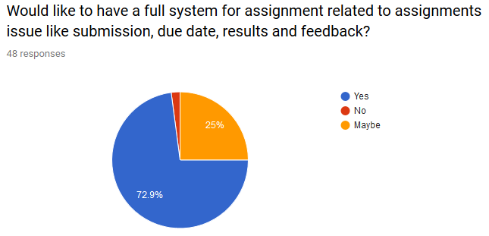

**Objective:** Getting students’ opinion of having full system handle all assignments aspects and issues.

**Analysis:** Here is students prefer a system that handles their assignments issues like the result, feedback, due date and online submission.

## 6.2 Summary

In Summary, this survey results founded the base requirements of the system. 35.4% of the students think that the traditional approach to submitting the assignment consumes a lot of their time, and 37.5% of the participants want to adopt online assignment submission system due to its speed of transmission. Thus, one of the non-functional requirements is performance. In addition, designing a user experience that builds a user interface that is simple to use and fast.

Besides that, security is an important topic to the students. Protecting their data and their documents, so it's won't get a steal or modified. 29.2% of the student's concern about their safety and privacy. Thus, security is another non-functional requirement stated as the most prior requirement. All students' data should be encrypted and protected to avoid any harmful attacks.

Finally, almost 73% of the students desire to have a full system that handles all assignments issues. Because of this, assignment results, feedback and booking presentation time are additional requirements to the system.

# 7- System Architecture

## 7.1- Introduction

### 7.1.1 – Authentication feature

It is required for all users to login and validate their input before using the system. Each user has a unique username and password to allow the system recognized who’s the user. All the users’ passwords are fully encrypted in the system database to make user data safe from attackers. When user’s login to the system successfully, the system will generate a token to validate their action while they use the system. Each HTTP request made by the users, the system with validate the token. Many advantages to use token to authenticate users’ action. First, it is a cross-domain solution. For security reason browsers prevent HTTP request from different region.

**Example:**

A screenshot of a cell phone

Description generated with very high confidence

But with using token authentication based, you can send HTTP request to any different server or domain. Another benefit of using token is decoupling. You are not forced to use any specific authentication schema. Token could be generated anywhere, especially when API is called from anywhere with only one single authentication.

(MDN web docs, 2018)

### 7.1.2 Start New Assignment

First main feature of the system is starting new assignments. This is a feature for lecturer to start in-course assignments. The system shall allow lecturer to start assignment and upload the assignment question and assign the due date. The lecturers shall have full authority to update the assignment question or modifying the due date. Students should get an email notification when a new assignment is started or updated.

### 7.1.3 Submit assignment

After a new assignment is started, students shall be able to upload their assignment to the system. The system shall allow student to reupload and update their assignments while the due date is not over. When the due date is over, students shall not be capable to update their assignment.

### 7.1.4 Manage Group Assignment

For group assignments. Lecturer shall be able to set up the maximum and minimum members on each group. In contrast, students shall be able to register and join into groups in the system.

### 7.1.5 Presentation

The system shall allow lecturer to determine presentation date and time, and then allow students to book their presentation time using the system.

### 7.1.6 Assignment Assessment

The system shall allow lecturer to download students’ assignments and assess them. Lecturers shall not be able to access to students’ assignment before the due date, to ensure that lecturers are accessed to the latest updated student assignment. After the lecturer has access to students’ assignments, he or she will be able to send the assignments assessment to the students.

### 7.1.7 View Assessment

Students shall be able to view their assignment result through the system. In addition, they also can read feedback from the lecturer about the assignment.

## 7.2- Abstract Architecture

### 7.2.1- System Design

#### 7.2.1.1 Use Case

A close up of text on a white background

Description generated with high confidence

##### 7.2.1.1.1 Use Case Description

|  |  |
| --- | --- |
| Use Case ID | UC1 |
| Name | Login |
| Summary | Users need to authenticate before they use the system |
| Priority | High priority |
| Pre-condition | -- |
| Post-condition | Users use the system if they are authorized. |
| Actor | Admin – Students – Lecturers |
| Main Scenario | 1. Users enter their username and password 2. System validate user’s username and password 3. If the information input is correct, the system will allow them to use the system. |
| Alternative path | If step 3 in main scenario not true, the system won’t allow the user to access the system. |

|  |  |
| --- | --- |
| Use Case ID | UC2 |
| Name | Start Assignment |
| Summary | Lecturers start new assignment for students |
| Priority | High priority |
| Pre-condition | User Must be Authenticate / Assignment should not be expired |
| Post-condition | New assignment in started |
| Actor | Lecturers |
| Main Scenario | 1. Lecturer selects module 2. Lecturer selects intake 3. Lecturer start new assignment for students |
| Alternative path | -Some intakes already got the assignment, in this case lecturer is only able to update the due date.  - if the assignment is expired they cannot start the same assignment again. |

|  |  |
| --- | --- |
| Use Case ID | UC3 |
| Name | Assign due date |
| Summary | Lecturer assign the due date for the students to submit the assignment |
| Priority | High priority |
| Pre-condition | User Must be Authenticate / Assignment should not be expired |
| Post-condition | Student can see the due date |
| Actor | Lecturers |
| Main Scenario | 1. Lecturer selects module 2. Lecturer selects intake 3. Lecturer start new assignment for students 4. Lecturer assign the due date |
| Alternative path | -Some intakes already got the assignment, in this case lecturer is only able to update the due date.  -if the assignment is expired they cannot start the same assignment again. |
| Use Case ID | UC4 |
| Name | Upload Assignment question |
| Summary | Lecturer upload the assignment question to the students |
| Priority | High priority |
| Pre-condition | User Must be Authenticate / Assignment should not be expired |
| Post-condition | Student can download the question |
| Actor | Lecturers |
| Main Scenario | 1. Lecturer selects module 2. Lecturer selects intake 3. Lecturer start new assignment for students 4. Lecturer assign the due date 5. Upload the question |
| Alternative path | -Some intakes already got the assignment, in this case lecturer is only able to update the due date.  -if the assignment is expired they cannot start the same assignment again. |

|  |  |
| --- | --- |
| Use Case ID | UC5 |
| Name | Arrange Presentation |
| Summary | Lecturer arrange presentation for students |
| Priority | High priority |
| Pre-condition | User Must be Authenticate |
| Post-condition | Student can reserve their presentation time. |
| Actor | Lecturers |
| Main Scenario | 1. Lecturer selects module 2. Lecturer selects intake 3. Lecturer selects presentation date 4. Lecturer select presentation time 5. System will generate the presentation booking table based on the duration. |
| Alternative path | ----- |

|  |  |
| --- | --- |
| Use Case ID | UC6 |
| Name | Form Groups |
| Summary | Lecturer form group for assignment group |
| Priority | High priority |
| Pre-condition | User Must be Authenticate / Assignment should not be expired |
| Post-condition | Students are able to join the groups |
| Actor | Lecturers |
| Main Scenario | 1. Lecturer selects module 2. Lecturer selects intake 3. Lecturer selects the minimum and maximum group member 4. The system will generate the groups equally based on the lecturer input for maximum and minimum members. |
| Alternative path | ----- |

|  |  |
| --- | --- |
| Use Case ID | UC6 |
| Name | Form Groups |
| Summary | Lecturer form group for assignment group |
| Priority | High priority |
| Pre-condition | User Must be Authenticate / Assignment should not be expired |
| Post-condition | Students are able to join the groups |
| Actor | Lecturers |
| Main Scenario | 1. Lecturer selects module 2. Lecturer selects intake 3. Lecturer selects the minimum and maximum group member 4. The system will generate the groups equally based on the lecturer input for maximum and minimum members. |
| Alternative path | ----- |

|  |  |
| --- | --- |
| Use Case ID | UC7 |
| Name | Update due date |
| Summary | Lecturer update the assigned due date |
| Priority | High priority |
| Pre-condition | User Must be Authenticate / Assignment should not be expired |
| Post-condition | Students are informed through email |
| Actor | Lecturers |
| Main Scenario | 1. Lecturer selects module 2. Lecturer selects intake 3. Lecturer updates the assigned due date 4. The system informs the students through an automatic email |
| Alternative path | if the assignment is expired lecturer cannot update the assignment submission date. |

|  |  |
| --- | --- |
| Use Case ID | UC8 |
| Name | Download Students Assignment |
| Summary | Lecturer download students’ assignment |
| Priority | High priority |
| Pre-condition | User Must be Authenticate / Assignment should be expired |
| Post-condition | ------ |
| Actor | Lecturers |
| Main Scenario | 1. Lecturer selects module 2. Lecturer selects intake 3. Lecturers download single student assignment or all of them at once |
| Alternative path | if the assignment is not expired lecturer cannot download the assignment answers. |

|  |  |
| --- | --- |
| Use Case ID | UC9 |
| Name | Assessment |
| Summary | Lecturer assess students’ assignment |
| Priority | High priority |
| Pre-condition | User Must be Authenticate / Assignment should be expired |
| Post-condition | ------ |
| Actor | Lecturers |
| Main Scenario | 1. Lecturer selects module 2. Lecturer selects intake 3. Lecturers set students grade and send feedback to students |
| Alternative path | if the assignment is not expired lecturer cannot assess students’ assignments. |

|  |  |
| --- | --- |
| Use Case ID | UC10 |
| Name | Download assignment question |
| Summary | Lecturer download students’ assignment |
| Priority | High priority |
| Pre-condition | User Must be Authenticate / Assignment should be assigned |
| Post-condition | ------ |
| Actor | Students |
| Main Scenario | 1. Student selects module 2. Students view the assignment information and download the question |
| Alternative path | if the assignment is not started, then students won’t be capable to download the assignment question. |

|  |  |
| --- | --- |
| Use Case ID | UC11 |
| Name | Check Due date |
| Summary | Students can check when they should submit their assignment |
| Priority | High priority |
| Pre-condition | User Must be Authenticate / Assignment should be assigned |
| Post-condition | ------ |
| Actor | Students |
| Main Scenario | 1. Student selects module 2. Students view the assignment information and due date |
| Alternative path | if the assignment is not started, then students won’t be capable to view the due date |

|  |  |
| --- | --- |
| Use Case ID | UC12 |
| Name | From group |
| Summary | Students from group with each other for group assignment |
| Priority | High priority |
| Pre-condition | User Must be Authenticate / Assignment should be assigned |
| Post-condition | ------ |
| Actor | Students |
| Main Scenario | 1. Student selects module 2. Students selects to join any group from the table |
| Alternative path | if the assignment is not started, then students won’t be capable to form a group assignment. |

|  |  |
| --- | --- |
| Use Case ID | UC13 |
| Name | Upload Assignment answer |
| Summary | Students upload their assignment to the system |
| Priority | High priority |
| Pre-condition | User Must be Authenticate / Assignment should be assigned |
| Post-condition | ------ |
| Actor | Students |
| Main Scenario | 1. Student selects module 2. Students upload their assignment to the system |
| Alternative path | if the assignment is not started, then students won’t be capable to upload the assignment answers. |

|  |  |
| --- | --- |
| Use Case ID | UC14 |
| Name | Book presentation |
| Summary | Students book their presentation time. |
| Priority | High priority |
| Pre-condition | User Must be Authenticate / Lecturer should select the presentation date |
| Post-condition | ------ |
| Actor | Students |
| Main Scenario | 1. Student selects module 2. Students reserve the empty presentation slot. |
| Alternative path | If the lecturer doesn’t select the presentation date, the student won’t be able to book presentation time. |

|  |  |
| --- | --- |
| Use Case ID | UC15 |
| Name | View Assignment grades |
| Summary | Students book their presentation time. |
| Priority | High priority |
| Pre-condition | User Must be Authenticate / grades must be approved |
| Post-condition | ------ |
| Actor | Students |
| Main Scenario | 1. The grade will be visible to the students on the module list |
| Alternative path | If the grades are not approved by the admin, then the grade won’t be visible to the students. |

#### 7.2.1.2 Class Diagram

A close up of text on a white background

Description generated with very high confidence

#### 7.2.1.3 Activity Diagram

##### 7.2.1.3.1 Lecturer Activity Diagram

A screenshot of a cell phone

Description generated with very high confidence

##### 7.2.1.3.2 Student Activity Diagram

A screenshot of a cell phone

Description generated with very high confidence

#### 7.2.1.4 Sequence Diagram

##### 7.2.1.4.1 Authentication Sequence

A screenshot of text

Description generated with very high confidence

##### 7.2.1.4.2 Start new Assignment Sequence

#### A close up of a map Description generated with very high confidence

##### 7.2.1.4.3 Download Students’ Assignments

A close up of a map

Description generated with very high confidence

##### 7.2.1.4.4 Assignment Assessment Sequence

#### A screenshot of a cell phone Description generated with very high confidence

##### 7.2.1.4.5 Arrange Assignment Groups

#### A close up of a map Description generated with very high confidence

##### 7.2.1.4.6 Download Assignment Question

A close up of a map

Description generated with very high confidence

##### 7.2.1.4.7 Submit Assignment

A close up of a map

Description generated with very high confidence

### 7.2.2 Database Design

#### 7.2.2.1 Entity Relationship Diagram

A close up of a map

Description generated with high confidence

#### 7.2.2.2 Non-rational Database Schema

A close up of a map

Description generated with high confidence

### 7.2.3 Interface Design

#### 7.2.3.1 Login

A screenshot of a cell phone

Description generated with very high confidence

#### 7.2.3.2 Lecturer Home

A screenshot of a social media post

Description generated with very high confidence

#### 7.2.3.3 Start New Assignment

A screenshot of a social media post

Description generated with very high confidence

#### 7.2.3.4 Download Student Assignment

A screenshot of a social media post

Description generated with very high confidence

#### 7.2.3.5 Assignment Assessment

#### A screenshot of a cell phone Description generated with very high confidence

#### 7.2.3.6 Manage Presentations

#### A screenshot of a social media post Description generated with very high confidence

#### 7.2.3.7 Students Home

#### A screenshot of a social media post Description generated with very high confidence

#### 7.2.3.8 Submit Assignments

#### A screenshot of a cell phone Description generated with very high confidence

#### 7.2.3.9 Join Assignment Groups

A screenshot of a cell phone

Description generated with very high confidence

#### 7.2.3.10 Book Presentations

A screenshot of a social media post

Description generated with very high confidence

# 8- project plan

## 8.1 Features Plan

|  |  |  |  |  |  |
| --- | --- | --- | --- | --- | --- |
| Task ID | Feature | Start Date | End Date | Duration | Priority |
| 1 | Authentication | 1st-6-2018 | 6th-6-2018 | 6 days | High |
| 2 | Start Assignment | 9th -6-2018 | 13th-6-2018 | 6 days | High |
| 3 | Submit Assignment | 16th-6-2018 | 21st-6-2018 | 6 days | High |
| 4 | Group Assignment | 24th-6-2018 | 29th-6-2018 | 6 days | Medium |
| 5 | presentation | 2nd-7-2018 | 7th-7-2018 | 6 days | Medium |
| 6 | Assess Assignment | 10th-7-2018 | 15th-7-2018 | 6 days | Low |
| 7 | View Assignment | 18th-7-2018 | 23rd-7-2018 | 6 days | Low |

## 8-2 Release Plan

### 8-2-1 Version 1.0.0 of Online Assignment Submission System

This is going to be the first release of the application to the end-user. It is going to be released on 1st of July 2018. This version is going to have authentication feature along with start and submit assignment. When this version is released, the users is going to be able to login and logout to the system. In addition, they can view all the available modules, so they can start new assignment and uploading their assignment.

### 8-2-2 Version 2.0.0 of Online Assignment Submission System

The second release of the system is going to have version 1.0.0 functionality plus managing group assignment and booking for presentations features. The release is going to be on 20th of July 2018. The users are going to able to manage their group. They can form groups depends on the rules that the lecturer determines about maximum and minimum members. Furthermore, the lecture can assign the presentation time and allow student to book their presentation time.

### 8-2-3 Version 3.0.0 of Online Assignment Submission System

The latest version is going to be about assessment and feedback. For this version, the lecturer can send their assessment and feedback to students. This version is going to be deployed on 1st of August 2018.

### 8-2-4 Release Plan

|  |  |  |
| --- | --- | --- |
| Version Number | Version Features | Deployment Date |
| **1.0.0** | * Authentication * Start Assignment * Submit Assignment | **1-7-2018** |
| **2.0.0** | * Group Assignment * Presentations | **20-7-2018** |
| **3.0.0** | * Assignment Assessment * View Assessment | **1-8-2018** |

## 8.3 Test Plan

Test-Driven Development is an evolutionary approach to development when you write a test before you write a function code. (Astels, 2003).

The process of making a test-driven is to write a test code first. Then test the testing code, if the testing is passed you start writing the function production code. If testing is not passed you need to make changes to the test code and try again. The following Activity diagram is showing the lifecycle of test-driven development

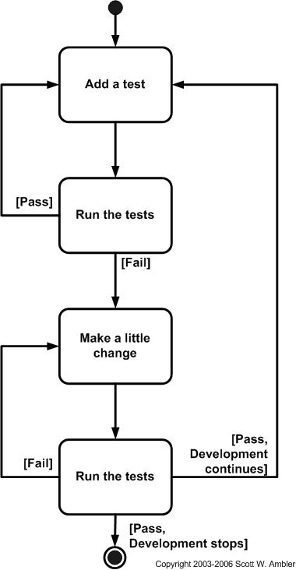

(Agile Data, 2018)

The benefits of using test-driven development is the simplicity of testing. This strategy makes it easier to test. If you write a function that has many lines and then run the system, there will be a high chance of broken system and failure. It is easier to find and fix error when you write couple of lines code than one hundred. Test-driven development makes the developer more productive to fix and build logic error and write a free-error code.

### 8.3.1 Unit Test Plan

For unit testing, the tester is going to use Mocha.js framework. “Mocha is a feature-rich JavaScript test framework running on Node.js and in the browser, making asynchronous testing simple and fun. Mocha tests run serially, allowing for flexible and accurate reporting, while mapping uncaught exceptions to the correct test cases”. (Mocha.js, 2018)

|  |  |  |  |
| --- | --- | --- | --- |
| Test ID | Function | Expected Output | Status |
| 1 | Authentication | The system should validate the user input and check if it is correct, if so allow the user to enter the system. Else throw error message |  |
| 2 | Start new Assignment | The system should allow lecturer to start new assignment and save the assignment to the database |  |
| 3 | Submit Assignment | The System should allow student to submit their assignment and save it to the database |  |
| 4 | Manage Group members | The System should allow student to form group together for group assignment and save group to the database |  |
| 5 | Book Presentation | The system should allow student to book presentation time and save the reservation to the database |  |
| 6 | Assessment | The system should allow lecturer to assess students’ assignment and write feedback and save it to the database |  |
| 7 | View Assessment | The system should allow student to view their assessment and feedback |  |

### 8.3.2 Test plan for User Acceptance Testing.

User Acceptance Testing (UAT) is the final stage of the software testing process. During the UAT test, actual program users test the program to ensure that it can handle the required tasks in real-world cases, according to requirement. UAT is one of the most important and final software project procedures that must happen before deploying newly developed software on the market. UAT is also known as a beta test, application test, or end-user test. (Techopedia, 2018)

For the proposed system, UAT is going to be made by three students. They are going to test the core functions of the system. Such as login, start assignment, submit assignment, form group, book presentation and view assessment. They also going to evaluate the software quality attributes like performance, availability and reliability. Finally, they going to assess the system user interface design and how convenient to use the system and how responsive is the system while using different screen devices.

### 8.3.2.1 User Acceptance Testing Template.

Name: ………………………………………………. Student ID: ………………….

Date: ………………………………………………. Time: …………………………

|  |  |  |  |  |
| --- | --- | --- | --- | --- |
| Category | Poor | Average | Good | Excellent |
| Authentication |  |  |  |  |
| Submit Assignment |  |  |  |  |
| Form Group |  |  |  |  |
| Book Presentations |  |  |  |  |
| View Assessments |  |  |  |  |
| Speed  “How fast is the system” |  |  |  |  |
| Reliability  “The ability not to fail” |  |  |  |  |
| Availability  “Able to use the system” |  |  |  |  |
| User Experience  “How convenient to navigate through the system” |  |  |  |  |
| Responsiveness  “convenient in different devices screen sizes” |  |  |  |  |

Additional comment: ……………………………………………………………………………………………………………………………………………………………………………………………………………………………………………………………………………………………………………………………………………………………………………………………………………………………………………………………………………………………………………………………………....

# 9- Implementation

## 9.1 Screenshot

### 9.1.1 Screenshot for login page

#### 9.1.1.1 Description

Login page contain two fields username text input and password text input. When user enter their authority credential, the client-side page will send AJAX request to the API server to validate the user’s information. If the input match the user’s information, the page will go to user home page, otherwise it will show authentication error message on of the page.

#### 9.1.1.2 Screenshot

A screenshot of a cell phone

Description generated with very high confidence

A screenshot of a cell phone

Description generated with very high confidence

### 9.1.2 Screenshot for home page

#### 9.1.2.1 Description

When authentication passed successfully, home page will appear for students and lecturer. When the home page is uploaded, AJAX request is sent to the server API to get all module that the lecturer teach or all the module that the student study.

#### 9.1.2.2 Screenshot

A screenshot of a cell phone

Description generated with very high confidence

Lecturer Home Page

A screenshot of a cell phone

Description generated with very high confidence

Student home page

### 9.1.3 Start new assignment

#### 9.1.3.1 Description

To start a new assignment, the lecturer needs to fill up a form which contain assignment details like module name, intake, title, type and due date. In addition, the lecturer is require to upload the assignment to the server to enable student reading the questions.

#### 9.1.3.2 Screenshot

A screenshot of a cell phone

Description generated with very high confidence

### 9.1.4 Manage Presentation

#### 9.1.4.1 Description

Lecturer can manage students’ assignment presentation date and time through the system. Lecturers enter presentation date and when presentation is starting and ending. They also need to enter the duration of each presentation. Then the system is going to make presentation slot allowing students to book their presentation time.

#### 9.1.4.2 Screenshot

A screenshot of a cell phone

Description generated with very high confidence

Make new presentation

A screenshot of a cell phone

Description generated with very high confidence

View Presentations

### 9.1.5 Download Students’ Assignments

#### 9.1.5.1 Description

Download assignments page contain a table that view all students’ submission. The table contain Student TP number, student name, submission date which appear in two color green if it is submitted on time and red if it is late submission, download link and assessment link.

#### 9.1.5.2 Screenshot

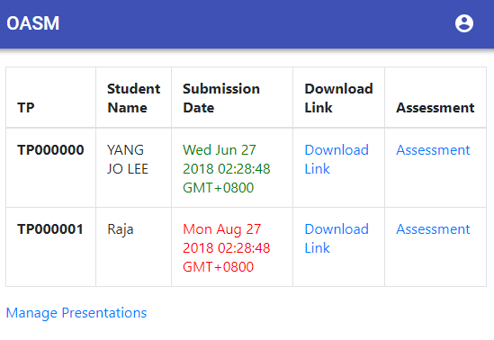

### 9.1.6 Submit Assignment

#### 9.1.6.1 Description

Students are free to submit their assignment and update it many time before the due date. All they need to do is to upload the assignment document and click submit. The system shall know if the student is submitting for the first time or updating the old submission.

#### 9.1.6.2 Screenshot

A screenshot of a cell phone

Description generated with very high confidence

### 9.1.7 Join Assignment Group

#### 9.1.7.1 Description

Student must join group for assignment group in the system to let the system know which group you are in when you submit the assignment. There is secret code for every group. When student wish to join any group, they need to provide secret code. Secret code will prevent unwanted student to join your group.

#### 9.1.7.2 Screenshot

A screenshot of a cell phone

Description generated with very high confidence

### 9.1.6 Book Presentation

#### 9.1.6.1 Description

The system shall make the presentation managing easier than before. Student can book their presentation slot through the system. The page will show the date day, starting and ending time.

#### 9.1.6.1 Screenshot

#### A screenshot of a cell phone Description generated with very high confidence

### 

## 9.2 Sample code

### 9.2.1 Sign in Code

A screenshot of a cell phone

Description generated with very high confidence

### 9.2.2 Uploading files

A screenshot of a social media post

Description generated with very high confidence

### 9.2.3 Download Files

A screenshot of a social media post

Description generated with very high confidence

### 9.2.4 Book presentation

A screenshot of a social media post

Description generated with very high confidence

### 9.2.5 Application states code

A screenshot of a social media post

Description generated with very high confidence

### 9.2.6 Middleware Authentication

A screenshot of a cell phone

Description generated with high confidence

# 10 System Validation

## 10.1 Unit Testing

All the unit testing was implemented using Mocha.js testing framework. And running the testing was done by using Windows Commands.

### 10.1.1 Lecturer Authentication unit test

#### 10.1.1.1 Unit test code

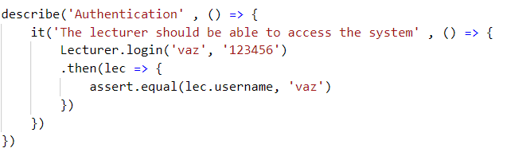

**Testing For correct username or password**

#### 10.1.1.2 Unit test command

A picture containing animal

Description generated with high confidence

**The testing case passed successfully**

#### 10.1.1.3 Unit test code

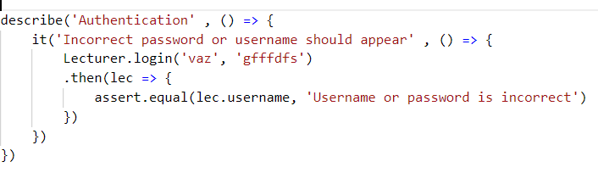

**Testing For incorrect username or password**

#### 10.1.1.4 Unit test code

A picture containing animal

Description generated with high confidence

**The testing case passed successfully**

### 10.1.2 Student Authentication unit test

#### 10.1.2.1 Unit test code

#### A screenshot of a cell phone Description generated with very high confidence

**Testing For correct username or password**

#### 10.1.2.2 Unit test command

A picture containing animal

Description generated with very high confidence

**The testing case passed successfully**

#### 10.1.2.3 Unit test code

A screenshot of a cell phone

Description generated with very high confidence

**Testing For incorrect username or password**

#### 10.1.2.4 Unit test command

A picture containing animal

Description generated with high confidence

**The testing case passed successfully**

### 10.1.3 Start Assignment unit test

#### 10.1.3.1 Unit test code

A screenshot of a cell phone

Description generated with very high confidence

#### 10.1.3.2 Unit test command

A picture containing animal

Description generated with high confidence

**The testing case passed successfully**

### 10.1.4 Submit Assignment unit test

#### 10.1.4.1 Unit test code

A screenshot of text

Description generated with very high confidence

#### 10.1.4.2 Unit test command

A picture containing animal

Description generated with high confidence

**The testing case passed successfully**

### 10.1.5 Join group assignment unit test

#### 10.1.5.1 Unit test code

A screenshot of a cell phone

Description generated with very high confidence

#### 10.1.5.2 Unit test command

A picture containing animal

Description generated with high confidence

**The testing case passed successfully**

### 10.1.6 Assignment assessment unit test

#### 10.1.6.1 Unit test code

A screenshot of a cell phone

Description generated with high confidence

#### 10.1.6.2 Unit test command

A picture containing animal

Description generated with high confidence

**The testing case passed successfully**

## 10.2 Unit Testing Summary

|  |  |  |  |
| --- | --- | --- | --- |
| Test ID | Function | Expected Output | Status |
| 1 | Authentication | The system should validate the user input and check if it is correct, if so allow the user to enter the system. Else throw error message | **Passed** |
| 2 | Start new Assignment | The system should allow lecturer to start new assignment and save the assignment to the database | **Passed** |
| 3 | Submit Assignment | The System should allow student to submit their assignment and save it to the database | **Passed** |
| 4 | Manage Group members | The System should allow student to form group together for group assignment and save group to the database | **Passed** |
| 5 | Book Presentation | The system should allow student to book presentation time and save the reservation to the database | **Passed** |
| 6 | Assessment | The system should allow lecturer to assess students’ assignment and write feedback and save it to the database | **Passed** |
| 7 | View Assessment | The system should allow student to view their assessment and feedback | **Passed** |

## 10.3 User Acceptance Testing

### 10.3.1 First User Testing

Name: ……Abdullah Sheikh Ahmed…………. Student ID: …TP040310…….

Date: …………1-8-2018……………………. Time: ……4:00PM…………

|  |  |  |  |  |
| --- | --- | --- | --- | --- |
| Category | Poor | Average | Good | Excellent |
| Authentication |  |  | √ |  |
| Submit Assignment |  |  |  | √ |
| Form Group |  |  |  | √ |
| Book Presentations |  |  |  | √ |
| View Assessments |  | √ |  |  |
| Speed  “How fast is the system” |  |  | √ |  |
| Reliability  “The ability not to fail” |  |  | √ |  |
| Availability  “Able to use the system” |  |  | √ |  |
| User Experience  “How convenient to navigate through the system” |  | √ |  |  |
| Responsiveness  “convenient in different devices screen sizes” |  | √ |  |  |

Additional comment: ……………………………………………………………………………………………………………………………………………………………………………………………………………………………………………………………………………………………………………………………………………………………………………………………………………………………………………………………………………………………………………………………………....

### 10.3.2 Second User Testing

Name: ……………Rayyan Abdulaziz……………. Student ID: ………TP040247………….

Date: ……………1-8-2018……………. Time: ……11:30PM……………

|  |  |  |  |  |
| --- | --- | --- | --- | --- |
| Category | Poor | Average | Good | Excellent |
| Authentication |  |  |  | √ |
| Submit Assignment |  | √ |  |  |
| Form Group |  |  |  | √ |
| Book Presentations |  |  |  | √ |
| View Assessments | √ |  |  |  |
| Speed  “How fast is the system” |  | √ |  |  |
| Reliability  “The ability not to fail” |  | √ |  |  |
| Availability  “Able to use the system” |  | √ |  |  |
| User Experience  “How convenient to navigate through the system” |  | √ |  |  |
| Responsiveness  “convenient in different devices screen sizes” |  | √ |  |  |

Additional comment: ……………………………………………………………………………………………………………………………………………………………………………………………………………………………………………………………………………………………………………………………………………………………………………………………………………………………………………………………………………………………………………………………………....

### 10.3.2 Third User Testing

Name: ………Abdulraheem Ali……………. Student ID: ……TP040249…….

Date: ………………2-8-2018…………………. Time: ……6:00PM…………

|  |  |  |  |  |
| --- | --- | --- | --- | --- |
| Category | Poor | Average | Good | Excellent |
| Authentication |  |  |  | √ |
| Submit Assignment |  |  | √ |  |
| Form Group |  |  |  | √ |
| Book Presentations |  |  |  | √ |
| View Assessments |  |  | √ |  |
| Speed  “How fast is the system” |  |  | √ |  |
| Reliability  “The ability not to fail” |  |  |  | √ |
| Availability  “Able to use the system” |  |  |  | √ |
| User Experience  “How convenient to navigate through the system” |  |  | √ |  |
| Responsiveness  “convenient in different devices screen sizes” |  | √ |  |  |

Additional comment: ……………………………………………………………………………………………………………………………………………………………………………………………………………………………………………………………………………………………………………………………………………………………………………………………………………………………………………………………………………………………………………………………………....

## 10.4 Summary

In summary, device testing and user acceptance testing were successfully carried out with the system and helped the developer identify faults that might have occurred in the system in the future and repaired them. In addition, the results of both tests helped the user to determine what system functions fulfilled his goals and what other functions replaced his goals. For unit tests, the programmer tested the main functions of the system and found that the entire function had successfully met the expected results. For User acceptance test, the students were overall satisfied with the final system result.

# 11. CONCLUSIONS AND REFLECTIONS

## 11.1 Critical evaluation

After inspecting the system, it demonstrates that the system has many features to help lecturers and students to work easily on their assignments. The first feature is secure authentication. The system authentication in handled using web token JSON which make the API server to validate and identify who made the HTTP request. Second, the lecturer can start and upload assignment question to students. The system made it easy to start a new assignment and upload the question to the system along with assignment details like due date, title and type. Third, student can submit their assignment using the system anywhere using any device. They can submit using smart phone or laptop and any time they like. Forth, the system made it easier to work with assignment related stuff like group and presentations. Student can join assignment group and book their presentation time through the system, which is a great feature to save time and organize the groups and the presentations. Finally, lecturer can send their assessment and feedback to students and students are able to view their assessment through the system.

## 11-2. Conclusion

To conclude the first phase of the project, let’s overview the outcome of this research. First, the problem background was discussed in detail and understand the problem well which an important factor is to develop a successful software project. The problem statement is identified and studied carefully. After discussing the problem, project proposal aims and objectives was determined according to the problem statement and natural of challenges. Following this, a heavy research for similar system and study its domain and technical issue also study how it was build, designed, and challenges they came across. As soon as the research study is done, software development methodology has been chosen which is scrum methodology. The selection of the methodology was due to a serval reason, these reasons are, scrum is an agile methodology, getting the user involve and the development process approach which is broke the system into small subsystem called sprint and at the end of each sprint a potential shippable product is ready. After that, the stakeholder was determined which consist of students, admins and lecturers. Getting requirement from stakeholders was done by using questionnaire, the reason to choose questionnaire elicitation technique to guarantee that it reaches to largest group of students as possible. Moreover, questionnaire is easy and cheap, there are no meeting requirement or money to pay to get use this technique and analysis the participants answers. The outcome of this questionnaire is a set of requirements that is have a high priority to be implemented on the first version of the system.

In conclusion, the investigation report was done by reading books and academic research. There was enough resource to read and gather enough information to assist me during the development process.

# References

Adell, L. (2018, March 7). *Benefits & Pitfalls of using Scrum software development methodology*. Retrieved from Belatrix: https://www.belatrixsf.com/blog/benefits-pitfalls-of-using-scrum-software-development-methodology/

Agile Data. (2018, 8 20). *Introduction to Test Driven Development (TDD)*. Retrieved from Agile Data: http://agiledata.org/essays/tdd.html

Astels, D. (2003). *Test-Driven Development: A Practical Guide: A Practical Guide.*

Barker, S. (2008). *Paperless assignment: moving forward or making time?* a: University of South Australia .

Center for Medicare & Medicaid Services . (2018, March 5). *SELECTING A DEVELOPMENT APPROACH* . Retrieved from CMS: https://www.cms.gov/Research-Statistics-Data-and-Systems/CMS-Information-Technology/XLC/Downloads/SelectingDevelopmentApproach.pdf

Jones, D. (1997, JAN 1). *Three generations of online assignment management*. Retrieved from ASCILITE: http://www.ascilite.org/conferences/perth97/papers/Jonesd/Jonesd.html

Jones, D. (2002). *Online Assignment Management: .* Australia: Central Queesland University .

Krishnan, N. (2018, March 5). *How to choose the right software development methodology*. Retrieved from Asahi Technologies: https://www.asahitechnologies.com/blog/how-to-choose-the-right-software-development-methodology/

Mak, J. C.-s. (1999). *The Electronic Learning Environment (ELE) for IT-based Course in Hong Kong.* Hong Kong: The Open Univesity of Hong Kong.

Malik, S. (2018, March 7). *pros and cons of scrum methodology*. Retrieved from quickstart: https://www.quickstart.com/blog/post/pros-and-cons-of-scrum-methodology/

MDN web docs. (2018, August 14). *Cross-Origin Resource Sharing (CORS)*. Retrieved from MDN web docs: https://developer.mozilla.org/en-US/docs/Web/HTTP/CORS

*Mocha.js*. (2018, Agugst 1). Retrieved from Mocha.js: https://mochajs.org/

Petre, B. A. (1997). *Teaching programming through paperless assignments: An empirical evaluation of instructor feedback.* UK: The Open University UK.

Quan, D. (2001). *Universities combat rising Internet plagiarism”, .* UK: Duke University .

Rahman, N. A. (2016). *Online Project and Assignment Submission.* Kuala Lumpur: Asia Pacific University.

*Scrum Guide* . (2017, November 1). Retrieved from Scrum Guide : http://www.scrumguides.org/scrum-guide.html

Techopedia. (2018, August 1). *User Acceptance Testing (UAT)*. Retrieved from Techopedia: https://www.techopedia.com/definition/3887/user-acceptance-testing-uat

**APPENDICES**

**Turnitin Report**

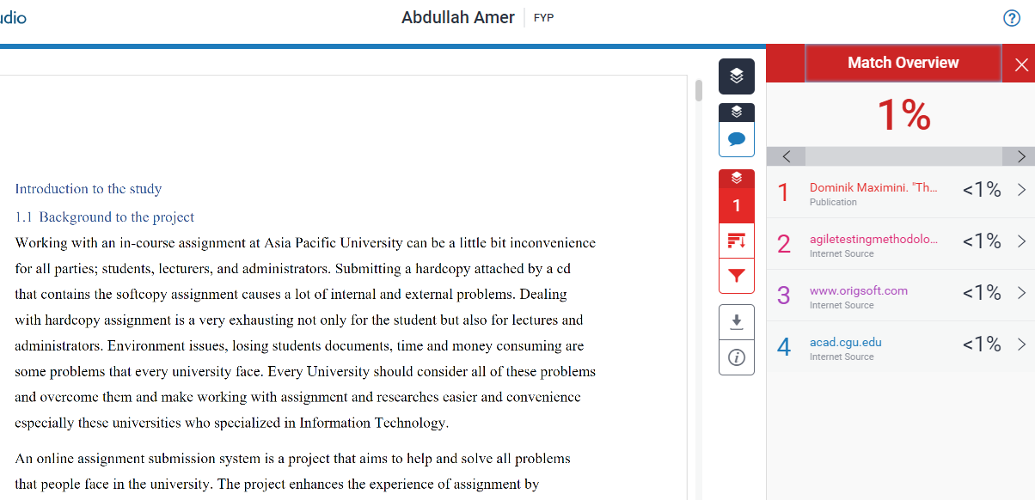

**Gantt Chart**

